

7th Grade English Language Arts

Units of Study

Welcome to 7th grade English Language Arts. I am looking forward to having you in my class. This year, we will be learning about how to analyze both fiction and informational texts, paying close attention to the elements that make up a story or argument. We will also apply our studies of literature by learning new writing skills and creating complex works of our own. We will be looking at texts from a variety of authors with all kinds of backgrounds in our studies. I hope all of you enjoy it just as much as I will!

Please have this syllabus signed and returned by August 10th.

Prof. Matthews

1. Development of Characters/Ideas

2. Central Ideas

3. Text Structure

4. Point of View

5. Summarizing Text

6. Text Analysis

Grading Policy

All grades in this class will be assigned to one of two categories: minor and major grades. Minor grades include classwork, quizzes, and other smaller graded assignments to assess progress. Minor grades will be worth 60% of a student’s grade. Major grades include tests, projects, and essays and will be worth 40% of a student’s overall grade. Grades will be interpreted as follows:

90-100 A

80-89 B

75-79 C

70-74 D

0-69 F

Classroom Supplies

* Pens
* Pencils
* Highlighters
* Composition Notebook
* 3 Ring Binder (Shared)
* Colored Pencils (Optional)
* Lined Paper (Optional)
* Sticky Notes (Optional)



Grade Recovery/Late Work

Any student is permitted to reattempt any major grade that they performed poorly on, provided they work with the teacher in a one-on-one conference prior to the reattempt. Once the reattempt has been completed, the grade will be changed to reflect the higher score.

When students have excessive missing work parents will be notified periodically through both email and a letter home until the missing work is completed and turned in.

Classroom Expectations

Be Respectful

Be Responsible

Be Ready

Be Safe

Classroom Rules

Raise your hand to ask a question or for assistance

Keep your hands and feet to yourself

Listen carefully and follow directions the first time they are given

Be in your seat and ready to learn before the bell rings

Keep cell phones and personal electronics in your backpacks or lockers at all times during class

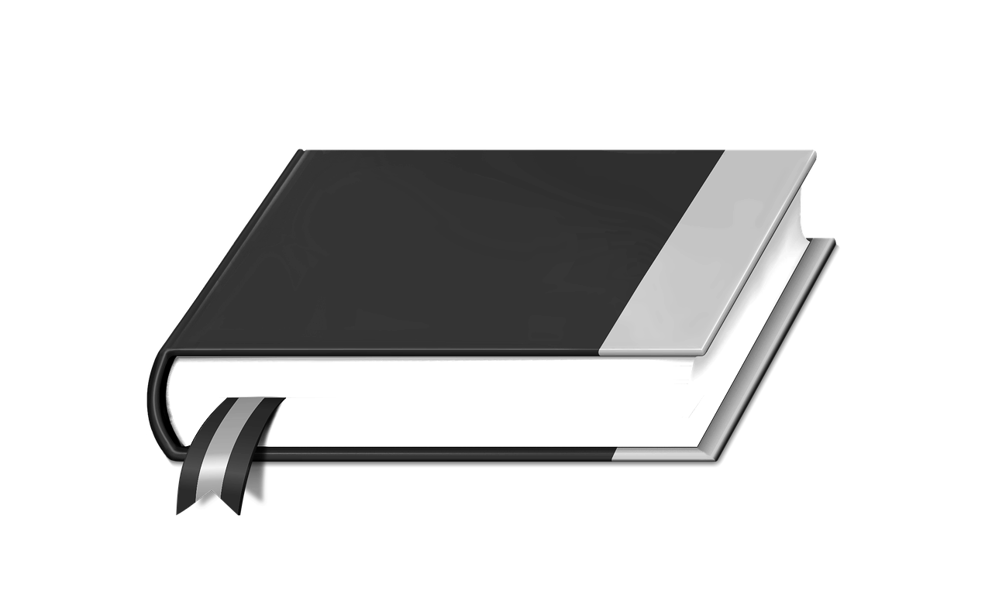

Prof. Matthews Class Schedule

1st Period: 7th Grade Honors English Language Arts

2nd Period: 7th Grade Honors English Language Arts

3rd Period: Planning

4th Period: Planning

5th Period: 7th Grade Honors English Language Arts

6th Period: Study Skills

7th Period: 7th Grade Honors English Language Arts

Conferences and Tutoring

Conferences can be set up by contacting me directly and will be held during planning periods or after school. Tutoring is also offered Monday-Thursday after school until 4pm with prior notice. To set up a time for tutoring, please email me or message me via Remind.

*Syllabus may change in the future

Please sign below to indicate that you have read and understand the policies and procedures outlined in this syllabus.

Student Signature: ______________________________________________

Parent Signature: _______________________________________________